CTE INTERNSHIP
Step-by-Step Applicant Gateway Guide for Students
Congratulations! A teacher or WBL Coordinator at your school has nominated you for a paid internship program administered by the Department of Education’s Work-Based Learning Resource Center. Below are step-by-step instructions for completing the online application and information about available Onboarding Sessions.
To be enrolled in payroll, you need to complete two steps:
- Complete the online Applicant Gateway
- Attend an Onboarding Session at the Work-Based Learning Resource Center.
You must wait for an e-mail from our office confirming that your application has been approved by HR, before you start work. According to DOE policy, no students are allowed to start work until they have received official notification that their application has been accepted. If you start work before being notified of your official start date, you will not be paid.
If you have any questions, contact your school’s WBL Coordinator, call our office at (718) 391-8558, or e-mail us at WBLBOX@schools.nyc.gov.
Follow the instructions below, and you will soon be on your way!
- Complete the online Applicant Gateway
Before you come to an Onboarding Session, you should complete your portion of the online application in the Applicant Gateway.
Preparation: you will need to have the following available in order to complete the Gateway:

- Your current e-mail (you must use the email you gave to your WBL Coordinator when you filled out your Parental Consent Form)
- Your Social Security Number
- Your phone number and home address (including apartment number)
- Your citizenship status
- For non-citizens, your Permanent Resident Card/Work Authorization Card/Work Visa
- An emergency contact including name, address and phone number

If you run into difficulties with the online application, please contact your WBL Coordinator. If your Coordinator cannot help you complete the Gateway, you should document the problems you experience and take screen shots of any problems you encounter. Bring your notes and these pictures with you to the Onboarding event, along with your I-9 documentation materials mentioned above, and on page 7 of this document.

- Click on the link below to access the Applicant Gateway. Enter your email address and the last four digits of your social security number on the webpage. Click “Send Password.”
https://www.nycenet.edu/Offices/DHR/agway/Start/GetPwd.aspx 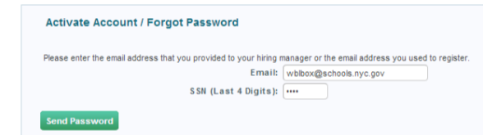

- As soon as you do this, you will receive an e-mail from AGSupport@schools.nyc.gov with the Subject: NYC DOE Applicant Gateway – Password Activation. Click on the link provided in the email.
- Enter a password twice as indicated - Your password must be at least 6 characters long. It must include CAPITAL LETTERS, lowercase letters, and at least 1 number. For example PASSword1. (Remember your password or write it down. If you forget or lose your password, go back to Step 1 to reset it). DO NOT PRESS ENTER
When done, click the green button that says “Update Password.” 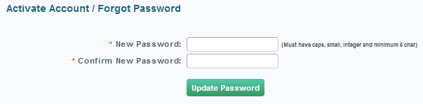

- You will be taken to the screen below. Follow onscreen instructions to log in using your e-mail and the password you just created.
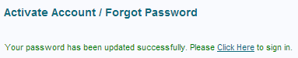 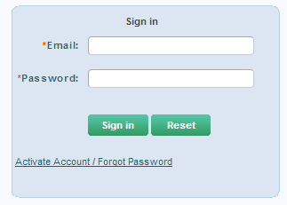
- Once you have logged in, there are three [3] items that you need to complete in the section of the table marked Forms Requiring Action (indicated on the screen shot below in red box):
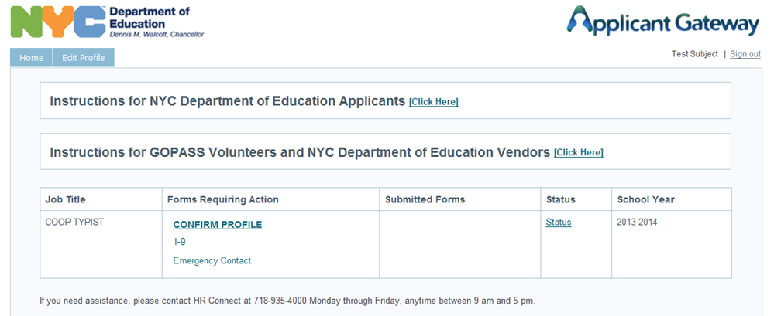

- Click on Confirm Profile first – this information is used to update all the other forms. Update all fields filled with the word UPDATE. All items marked with a red * must be completed; you cannot move forward without these items.
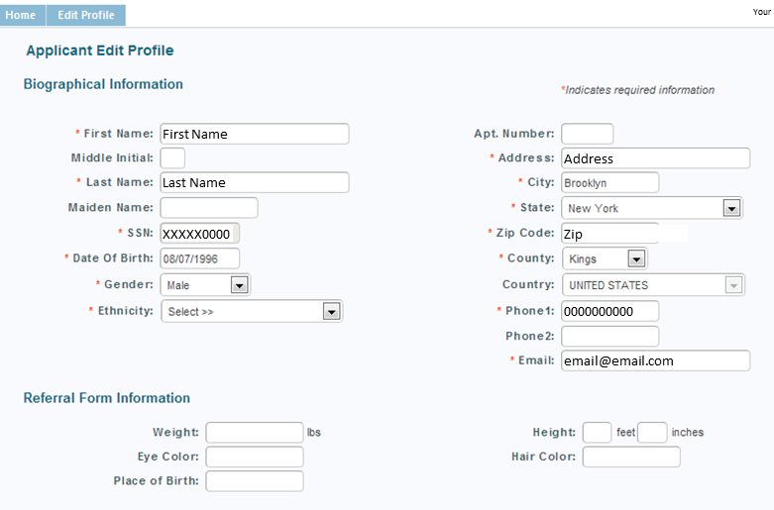
- When you have completed the above information scroll down to the bottom of the screen. At the bottom of the page, select your citizenship status, complete any additional fields as requested, and press the green “Confirm” button when done.
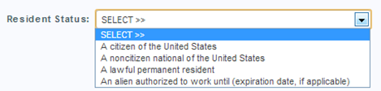 | 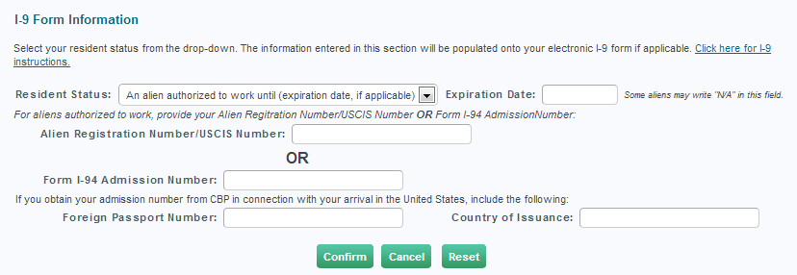
After you hit “Confirm”, you will be sent back to the home page, which should look like the shot below.
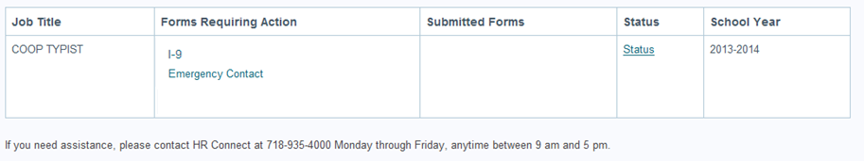
Notice that there are now only 2 items listed under Forms Requiring Action. As you complete each piece of the application, it will either disappear, or move to the column marked Submitted forms. This will help you track your progress.

- Next, select the I-9 form. Use the scrollbar on the side to find page 7, as shown in the picture. Check that all information is correct, check the small box at the bottom, and press the “E-sign” button. (If there are errors, click the “Edit Profile” button and make corrections. (All required items are boxed in red.)
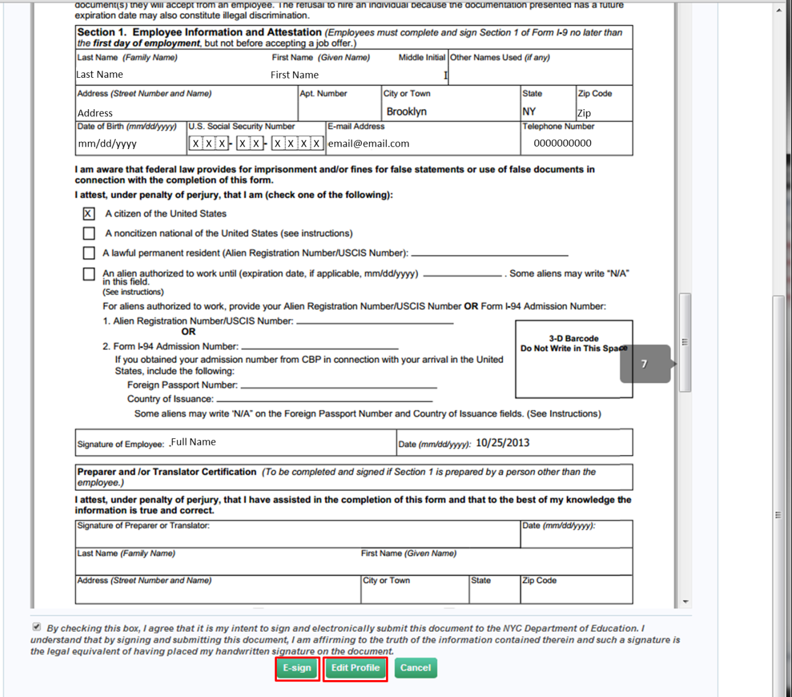
You’re almost there! After you e-sign, you’ll go back to the home page again, and should see the following:
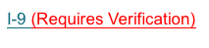
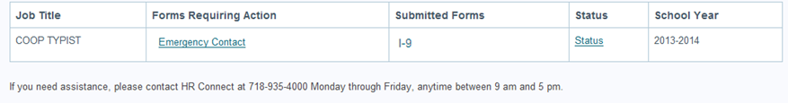

- Next, select the Emergency Contact form, and complete all items with a red *. Do not complete more than one Emergency Contact. When done, press the green Submit button at the bottom of the screen.
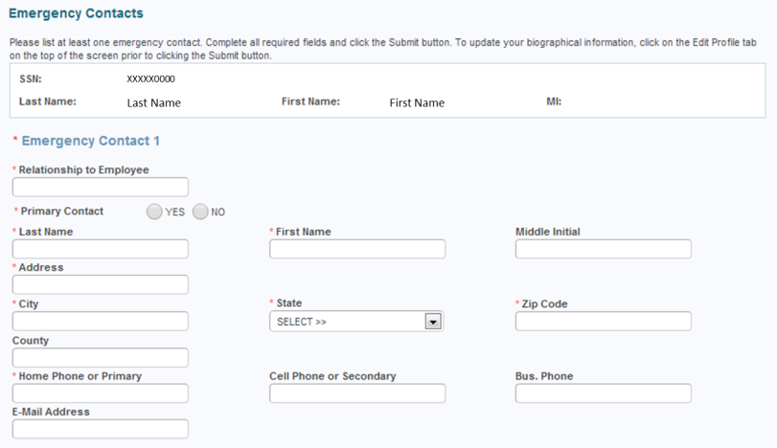 To complete:
- When all forms are completed, and you see nothing in the table under Forms Requiring Action, click Sign Out at the top right corner of the screen.
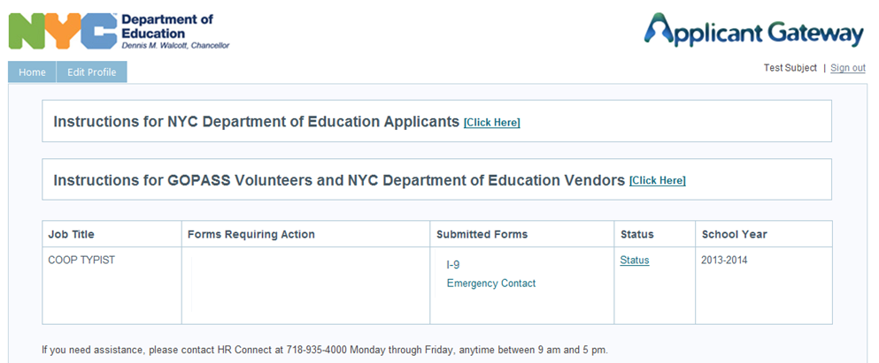
Once you have completed the steps above and your WBL Coordinator has seen and checked off your I-9 documentation, you are ready to take the next step, and come to an onboarding session!!

- Attend an Onboarding Session at the Work-Based Learning Resource Center.
All sessions will take place at our office:
28-11 Queens Plaza North, 4th Floor, Computer Lab
Long Island City, NY 11101
Below is a list of dates and times when we will be holding sessions. Please pick a date and time that work for you. Arrive early – sessions will end at promptly at the time listed. If you think you might be late, call our office at (718) 391-8558 and we will let you know if we can stay late to accommodate you.
DAY | DATE | TIME
WED | 10/15/14 | 2-5:30PM
TUES | 10/21/14 | 2-5:30PM
WED | 10/29/14 | 2-5:30PM
THURS | 11/6/14 | 2-5:30PM
MON | 11/10/14 | 2-5:30PM
WED | 11/19/14 | 2-5:30PM
TUES | 11/25/14 | 2-5:30PM
Preparation: you will need to bring the following with you the Onboarding Session:

- Acceptable Documents for I-9 Verification (see next page)
- Your current e-mail (the one you gave to your WBL Coordinator when you filled out your Parental Consent Form)
- Your phone number and home address (including apartment number)
- The name and contact information for an emergency contact

Before coming to an Onboarding Session, you should have completed your portion of the online application in the Applicant Gateway. If you ran into difficulties with the online application, please bring the documentation of the problems you experienced, and the screen shots you took with you to the onboarding event, along with your I-9 documentation materials.
When arrive for the onboarding sessions, you will be asked to show your documents to a staff member who will review them, complete the form required by HR, and check your status in the Gateway system. You must wait until a staff member confirms your Applicant Gateway is complete before you leave.
Once you have attended the Onboarding Session, you must wait for an e-mail from our office confirming that your application has been approved before starting work. According to DOE policy, no students are allowed to start work until they have received official notification that their application is complete. If you start work before being notified of your official start date, you will not be paid.

I-9 Verification – Acceptable Documents
Below are samples of what you will need to bring with you to the Onboarding Event. Please do not arrive at the event without these materials – students who come to the event without their documentation will be sent home, and their WBL Coordinator will be notified.
I. Working Papers (required for all students under 18)  These are issued in the school. Student must present green card (for 16-17 year olds) or blue card (for 14-15 year olds).  Application for working papers and doctor’s notes will not be accepted; please submit those to your school, which will issue this card.  If you are 18 or older, these are not required. | 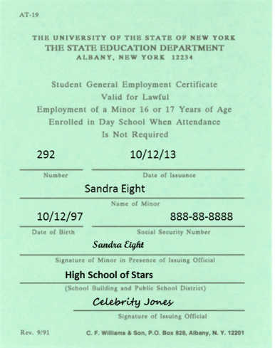
II. Documents that establish identity: All students must bring Photo ID. This can be a school ID, or any state-issued photo ID including driver’s license, or state ID. (Photo ID is also required to enter the building).
III. Documents that establish eligibility to work: Social Security Card, U.S. Passport, or Birth Certificate
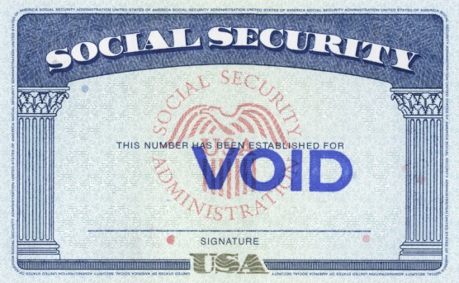 | 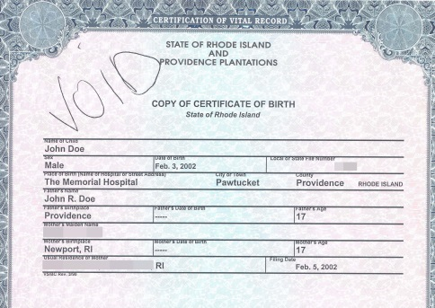
If your Social Security Card contains any of the following disclaimers, you will need to provide additional documentation for non-citizens: 1) NOT VALID FOR EMPLOYMENT, 2) VALID FOR WORK ONLY WITH INS AUTHORIZATION, 3) VALID FOR WORK ONLY WITH DHS AUTHORIZATION.
Federal Documents that establish both identity AND eligibility to work – if you have any of the documents below, only one is required (plus Working Papers, if under 18).
 | For non-citizens: Permanent Resident Card or Employment Authorization Card
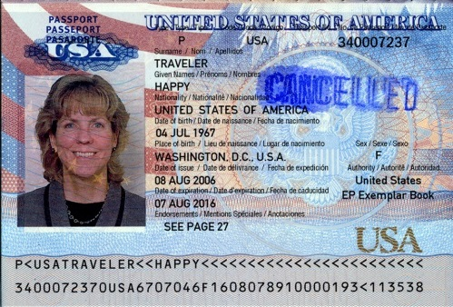 | 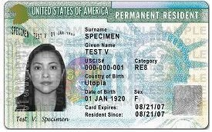 | 