Student Journal Activity 4 pH: Acidity and Aquatic Environments

A. Introduction to pH and the pH scale
1. For an animal living in pH 7 water, how much more acidic is pH 5 water?

B. pH in the Environment
2. What are two natural factors that could affect the pH of a stream?

3. What are two examples of human activities that can change the pH of a stream?

C. Acid Rain
4. What is the pH range of normal precipitation (rain and snow not affected by acid
rain)?

5. According to the diagram below, what is the approximate pH of a normal stream – a stream not affected by acid rain?
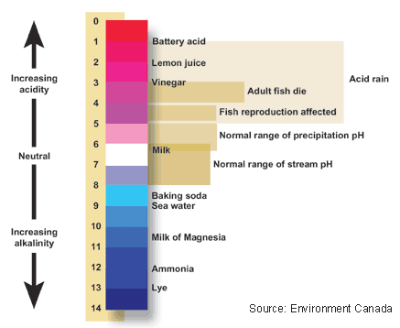

6. What is the pH range of Acid Rain, as shown in the above diagram?

Below is a map that shows the pH of rain samples from across the continental US in 1994. 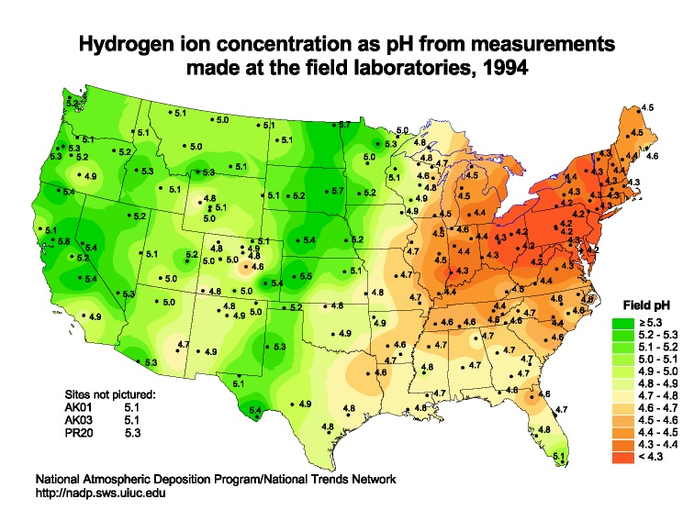

7. What do you notice about the differences in the pH of rainfall across the country in 1994? Which part of the country had rainfall with the lowest pH?

8. What was the average pH of rainfall in New York in 1994?

Fortunately several laws passed a few years earlier started taking effect. The laws required power plants to reduce their emissions of sulfates and nitrous oxides, both of which contributed to acid rain. Compare the 1994 map above with a similar map produced in 2009, seen below.
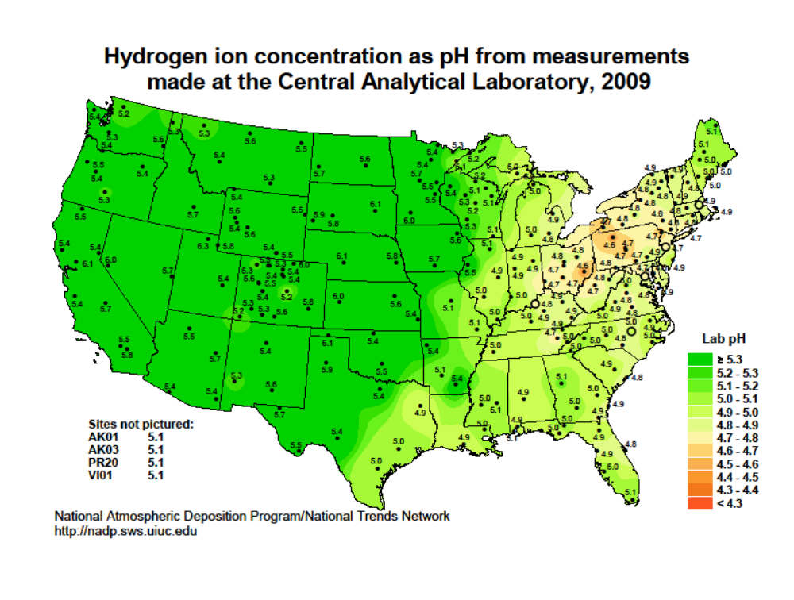
9. How has the picture changed in 16 years?

10. What was the pH of rain falling in New York in 2009?

11. Compare this figure with the level defined as acid rain on the diagram you looked a
at earlier. Would you say that the acid rain problem in New York was over in 2009, or was New York still experiencing acid rain?

D. What else can be done?
12. What are 3 things families can do to help reduce acid rain?

13. What is something you are willing and able to do right now?

E. Acid rain in Cascade Brook?
Examine the Cascade Brook graph of pH for Jan 2, 2009 – Dec 31, 2010 and consider the following questions:

14. Remember that a normal stream or brook has a pH of between 6 and 8. In general, how does the pH in Cascade Brook compare with that of a normal brook?

15. Did the pH in Cascade Brook ever fall within the pH range for acid rain, as indicated on the chart above? On what dates did this happen?

16. Notice that on some of these dates the graph shows sharp downward spikes. What are some possible causes of these abrupt low pH events?

Read the Instructions in the Student Guide about constructing the pH and rainfall graphs for Oct 24 - Nov 3, 2009. Download them into your Journal, compare the graphs and answer the question below:

17. What do you observe about the timing of rainfall with the pH changes on October 29th? What’s a possible explanation?

The Student Guide asks you to examine another time period, August 15 – 24, 2009, which also contains a downward spike in pH. Construct the pH and rainfall graphs for this period, download them into your Journal, compare them and consider the following question:

18. Is there any correspondence between the drop in pH and rainfall on August 20, 2009?

F. Aquatic animals and pH
How does the changing pH in Cascade Brook affect aquatic animals in general and your selected animal in particular? Look at the chart of pH requirements in the Student Guide and then compare your animal’s pH requirements with the 2009 pH graph you made earlier.

19. Was the pH at Cascade Brook ever outside the optimum range for your organism? When?

20. Would your study organism have experienced pH stress at any times during this period? Indicate those times on the graph using a red pencil or pen. What might it have done to try to minimize the effects of stress?

21. Compare your animal with someone else’s. Would their animal survive or experience stress?

