RESCUED FROM THE BRINK: RESTORATION OF EELGRASS, ZOSTERA MARINA, TO THE UPPER NEW YORK BAY
Research Draft
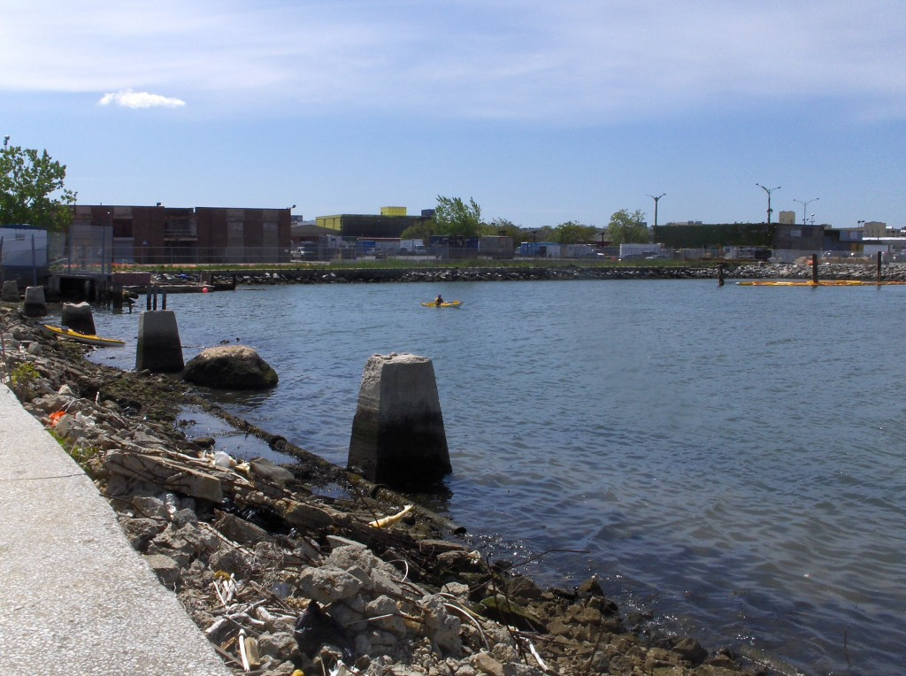
Photo Credit: B. Chezar, 2012
Prepared by: Nicolle Martinez
Directed by: Stephen Schott, Cornell Cooperative Extension,
Marine Botany/ Habitat Restoration Educator
Advised by: Mauricio Gonzalez, New York Harbor School
Bart Chezar, Citizen Scientist

Urban Assembly New York Harbor School
Marine Biology Research Program
New York
2014
- Abstract:
Eelgrass populations have declined since the 1930’s and has since failed to fully return, affecting bivalve, mollusk, and waterfowl populations as well as negatively impacting the fishery industry based around it (Muehlstein, 1989, making human intervention necessary. Eelgrass was planted in Pier 5, Sunset, Brooklyn by being woven into 8” burlap circles and has survived since 2012. Each trial has consisted of approximately 20 tortillas set into clusters of 3, with 10-12 blades of eelgrass woven through each one. Surviving eelgrass is currently being monitored using a quadrant to determine quadrantal percent coverage over time, which will give insight into the growth, spread, and declination of the vegetation. By assessing the percent coverage, visually interpreting the overall health of planted eelgrass, and measuring chemical and physical parameters of the water, it can be deduced that future restoration attempts in similar environments are plausible. With water quality remaining relatively cyclic through the seasons, temperature staying within or near the tolerance level of approximately 20ºC, and sufficient light penetration, the Pier 5 site is suitable for the survival and spread of transplanted eelgrass. This project and its findings will serve as a baseline for methods and reference for future eelgrass restoration projects in the Upper New York Bay and areas like it.

- Table of Contents:
Topic Page
Introduction 4
Background Information 5-6
Project Design Chart 7-8
Locality 9
Materials 10-13
Procedures 14-23
Observations and Results 24-29
Analysis of Results 29-30
Conclusions 31
Bibliography 32-33
Suggestions for Improvement and New Research Ideas 340

- Introduction:
Eelgrass declined by as much as 90-99% off of the coasts of North America, Europe, and Japan in 1930 when a slime mold, Labyrinthula zostera, and an abnormally hot summer took its toll on the light and temperature sensitive vegetation (SeagrassLi.org, 2012; Muehlstein, 1989). The return of this vegetation is significant to the survival, food web, and reproduction of many aquatic organisms that have been affected due to its lost. Such organisms include species of waterfowl who use eelgrass as a food source, species of mollusks and crustaceans that use the vegetation as a nursery, and bivalves that attach themselves onto eelgrass (Muehlstein, 1989). This project has as its main goal to help this organism to repopulate in the ecosystem. The assessment of a planting site and the monitoring of the eelgrass are key to understanding the impacts of eelgrass to the specific area, appropriate methods to use, and whether or not future restoration attempts would be plausible. Water quality monitoring of parameters such as nutrients, temperature, and light penetration are used to correlate growth progression of eelgrass with the water it lives in. Organism identification is used to understand how the eelgrass and surrounding fauna or flora coexist and assess relationships between the two to determine whether or not eelgrass has been impacting the area. The eelgrass growth and spread is currently being monitored with a m² quadrant to quantify quadrantal percent coverage. With water quality remaining relatively cyclic through the seasons, temperature staying within or near the tolerance level of approximately 20ºC, and sufficient light penetration, it is hypothesized that the Pier 5 site is suitable for the survival and spread of transplanted eelgrass.
- Background Information:
Eelgrass, Zostera marina is a sub-aquatic vegetation that died out in the 1930’s from the Atlantic Coasts of North America and Europe. (Schott, pers. comm. 2012). The massive die-off of approximately 90% of eelgrass due to a marine slime mold, Labyrinthula zostera, left many species of water fowl and sessile organisms without a major food source, nursery, or shelter. (Muehlstein 1989, Schott, pers. comm. 2012). Human activity has led to the degrading of water conditions and the undoing of natural habitat which eelgrass is native to. These activities include dredging, over harvesting, and the dumping of unsafe wastes into local water bodies. (Lynch, pers. comm. 2012; Moore, et al. 2012). Eelgrass is a vegetation with important ecological characteristics. The presence of eelgrass in an ecosystem serves to provide animals with food, shelter, and nursery, and providing a job industry for humans while also dampening currents, tides, and storms, which protects shorelines from damage. (Muehlstein 1989, Heck Jr. et al. 2012). Natural eelgrass return has proved difficult and slow due to anthropological activities (Cole, et al. 2012; Heck,Jr. et al. 2012). Pier 5 of Sunset, Brooklyn, New York is a collapsed cement pier and has been relatively untouched since its collapse. This area serves as protection to the vulnerable, newly planted eelgrass. The pier and the surrounding pilings are shelter to a variety of sessile organisms including Oysters and Blue Mussels. Eelgrass beds are inhabited by juvenile lobsters, sessile organisms, and epiphytes (Muehlstein, 1989). Eelgrass beds are a source of food for marine avian species such as Brant Geese (Schott, 2012). In order to assess the potential for survival and prosperity, chemical parameters of the water including Dissolved Oxygen, Nitrites, Nitrates, and Ammonia were measured. The temperature and light penetration are two vital factors due to the fact that eelgrass requires at least 11% irradiance (Short et al. 2002, Palacios et al. 2007) and is unable to survive in temperatures exceeding 20°C (Moore et al. 2012, Schott, pers. comm. 2012).

- Project Design Chart:
Table 2: Project design chart identifying the objectives, variables, and limitations associated with Eelgrass restoration to Pier 5.
Problem:
- Can eelgrass successfully be planted in the Pier 5, Sunset, Brooklyn area?
- If so, how successful will it be?
- Can the eelgrass spread on its own?
Hypothesis:
- Eelgrass will spread.
Objectives:
- Determine the spread of eelgrass at Pier 5.
Limitations and Risks:
- Access to pier is limited, inhibiting the ability to visit the site often.
- Tidal heights restrict the amount of time and when the eelgrass is visible and reachable.

- Locality:
The planting site is Pier 5 of Sunset, Brooklyn, N.Y. It is a collapsed cement pier, which would serve as a barrier for tides and currents that could possibly wash away the eelgrass. 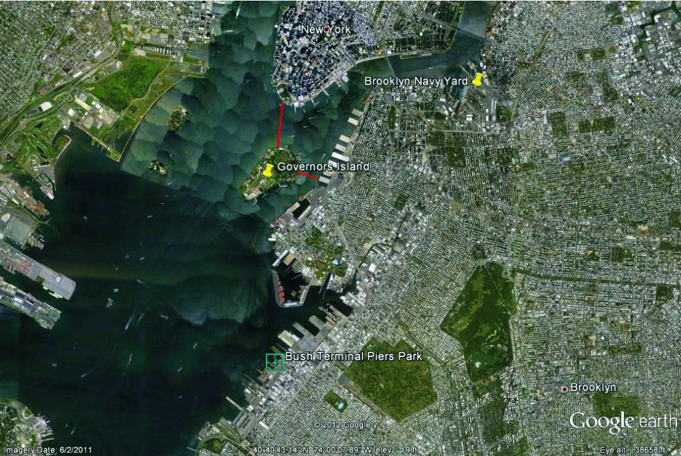
Figure 1: A map of the planting site location: Pier 5, Sunset, Brooklyn. The coordinates are 40.6456°N, 74.0119°W. Photo Credit: Google Earth

- Materials:
Table 1: Material, quantity, and purpose of all items used.
Material | Quantity | Purpose
 | Planting of Eelgrass
Eelgrass shoots | 160 | To plant into site sediment
Tortillas of Burlap (8) | 40 | Stabilize shoots
Igloo Cooler (28 qts) | 1 | Transport Eelgrass
Icepacks | 2 | Keep Eelgrass cool
Newspaper | 2 sheets | Keep Eelgrass moist
RO/DI water | various | Clean equipment
5 Gallon bucket (with lid) | 3 | Transport equipment
PVC core (8”) | 1 | Plant Eelgrass
Shell | 1 | Dig substrate
 | Data Collection
AquaCheck Nutrient Pond Test Strips | 32 | Test nutrients
Aquacheck Ammonia Pond Test Strips | 32 | Test Ammonia
20mL sample vial | 1 | Ammonia testing
SofChek Hardness Strips (cat: 27452-50) | 32 | Test Hardness (CaCO₃)
AquaCheck Phosphate Pond Test Strips (cat: 27571-50) | 32 | Test Phosphate (PO₄)
LaMotte D.O. Kit Code:5860-01 | 1 | Test Dissolved Oxygen
Dichotomous key * | 1 | Organism Identification
HOBOware PRO ver. 3.5.0 | 1 | Analyze light/temp. data
HOBO Pendant Temp/Light Logger (UA-002-64) | 1 | Collect light/tempt data
HOBO Optic USB Base Station (Part No. Base-U-4) | 1 | Connect logger to computer
Onset Coupler for Pendant (Coupler 2-A) | 1 | Connect logger to base
Hanna Combo Sensor (HI 98129) | 1 | Test electric conductivity, temp., and pH
Thermometer (Aquatic EcoSystems Inc) | 1 | Test temperature
Refractometer (SN: B005092) | 1 | Test Salinity
1 mL dropper | 1 | Collect Refractometer sample
Secchi Disc | 1 | Depth/Turbidity
m² PVC quadrant | 1 | Test percent coverage
Kim/AccuWipes | 32 | Clean/dry Refractometer
Aqua-Vu Micro AV w/ DVR 5 Underwater Viewing System (No. 503020130375) | 1 | Record date (video/still images)
GoPro Hero 3 | 1 | Still photographs on Quadrant
 | Other Equipment
Rope (marked at every meter) | 1 | Secchi disc
100mL container | 1 | Temp./light logger
Thin rope | 40cm | Temp./light logger
Stopwatch – SperScientific (code: 110596965-01) | 1 | Keep time during testing
Tape measure | 1 | Measure length
Storage solution | 1 | Hanna Combo Sensor upkeep
1000mL Waste water container | 1 | Transport waste water
Meter stick rod | 1 | Measure Eelgrass
Base | 1 | Neutralize waste water
Snorkel | 1 | Snorkeling
Full-face mask | 1 | Snorkeling
Aqua shoes | 6 pairs | Protect feet
Wetsuit | 1 | Swim/snorkel
Weight belt | 1 | Buoyancy control
3lb Weights | 3 | Buoyancy control

VIII. Procedures:
Weaving Eelgrass
- Enlarge openings of the 8” burlap circle such that there are space for 20 shoots, with 2 openings per shoot.
- Weave 20 eelgrass shoots through openings.
- Place “tortillas” (burlap circles) in tank until use.
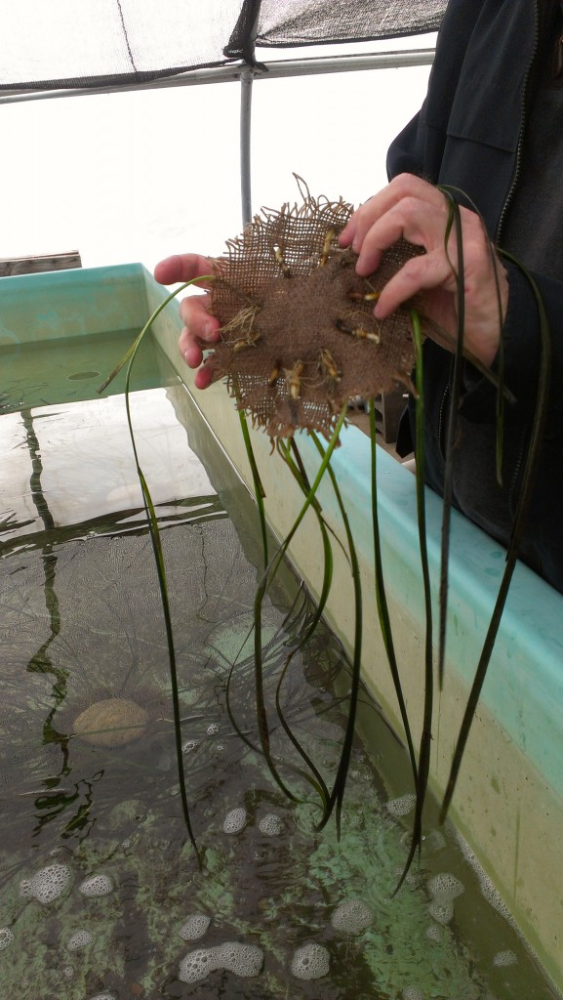
  - Image 1: Burlap “Tortillas” of Eelgrass before Planting.

Transport “Tortillas”
- Put eelgrass tortillas in cooler.
- Add enough water from the tank to cover half of the eelgrass.
- Cover the eelgrass with wet newspaper.
- Add icepacks if the time of transport is extensive.
- Transport eelgrass within 24 hours.
Note: Keep cooler containing eelgrass as cool as possible, outside of direct sunlight or spaces containing temperatures exceeding 72°F.
Plant Eelgrass
- Go to desired planting location.
- Put 2” wide PVC pipe measuring 8” in diameter onto sediment.
- Using a shell, dig a 2” deep hole into the sediment of the area enclosed by the pipe.
- Put the tortilla into the opening.
- Cover the tortillas with sediment.
- Carefully remove the PVC pipe, as not to remove any shoots or pull up the tortilla from the sediment.

Marking Plots
- Plant eelgrass tortillas in a circular arrangement.
- Put yard long stake into center of cluster of eelgrass.
- This marks the location of clusters for future identification.
Percent Coverage
- Place quadrant over eelgrass clusters, with cluster in the center.
- Using GoPro Hero Camera, take a still photograph of the quadrant and its subsections via aerial view.
- In lab, only count squares with the sprouts of eelgrass coming out of the sediment.
- Multiply number of squares by 10. This is the Percent (%) Coverage.
Water Quality
Measuring Temperature, and pH
- Rinse the Hanna Combo Sensor with RO/DI Water.
- Turn on the Hanna Combo Sensor.
- Press “Set” until the screen reads “pH” in the upper right hand corner.
- Put Hanna Combo Sensor in the water sample.
- Wait until the screen has steadied and the numbers no longer change.
- Record the pH (large number on the screen) and the temperature (small number underneath the pH.)
- Rinse the Hanna Combo sensor with RO/DI water.
- Add 3 drops of storage solution to the cap of the Hanna Combo Sensor.
- Cap the Hanna Combo Sensor.
Testing Turbidity
- Latch a rope marked at every meter to the secchi disc.
- Lower the disc into the water.
- Once the black and white target is no longer visible, stop lowering the disc.
- Make note of how many meters deep the secchi disc went.
- To clean: rinse all metal components with RO/DI water.
- Unlatch rope from disc, coil the rope, and store in a dry place.
LaMotte Dissolved Oxygen (Winkler Method)
- Collect sample in sample bottle by fully submerging bottle and cap.
- Close the bottle underwater (let there be no bubbles inside the bottle.)
- Uncap the bottle.
- Add 8 drops of Manganous Sulfate.
- Add 8 drops of Alkaline Potassium Iodide Azide.
- Cap bottle.
- Turn bottle upside down and right side up slowly, repeating this motion until components mix.
- Set down and allow for precipitate to fall below the shoulder of the bottle.
- Uncap bottle.
- Add 8 drops of Sulfuric Acid.
- Cap bottle.
- Turn bottle upside down and right side up slowly, repeating this motion until components mix.
- Pour 20mL into titration cup.
- Cap titration cup.
- Draw 10mL of Thiosulfate into syringe.
- Add Thiosulfate into titration cup slowly while titrating until solution is a pale yellow.
- Uncap titration cup.
- Add 8 drops of starch indicator. Solution will turn a purple color.
- Titrate while adding more Thiosulfate until the solution is clear.
- The number on the side of the plunger is the D.O.
Note: In the event that the syringe must be refilled, the following formula must be used to calculate the Dissolved Oxygen:
y=10x+z
Where x is the number of times the syringe was refilled, z is the number on the side of the syringe, and y is the resulting D.O. (i.e. if the syringe is refilled twice and the syringe reads 4, 10(2)+4=20+4=24 ppm.)
- Dispose of unused Thiosulfate, liquid in sample bottle, and liquid in titration cup in waste water container to be neutralized later.
Neutralizing Waste Water
- Turn on Hanna Combo Sensor.
- Rinse off with RO/DI water.
- Set to pH.
- Put Sensor in water.
- Add Base to the waste water until the Sensor reads between 6.8 and 7.2
- The waste water is now safe to pour down a drain.
Test Hardess (CaCO₃)
- Dip strip into water for 1 second.
- Shake off excess water.
- Hold strip level, pad side up, for 15 seconds.
- Compare pad with color chart.
- Dispose of strips.
Testing Nutrients
- Dip strip into water for 30 seconds.
- Do not shake excess water from strip.
- Hold strip level, pad side up, for 30 seconds.
- Compare pH, Buffering capacity, and Nitrite pads to color chart.
- Wait another 30 seconds.
- Check Nitrate pads with color chart.
- Dispose of strips.
Testing Ammonia
- Fill sample vial with 20mL of water.
- Move strip vigorously up and down. Make sure both pads are always submerged.
- Shake off excess water, and hold strip level for 30 seconds, pad side up.
- To collect reading, turn strip pad side down, and compare color with color chart.
- Dispose strips.
Testing Phosphate
- Dip strip into water for 5 seconds.
- Hold strip level, pad side up, for 45 seconds. Do not shake off excess water.
- Compare pad with color chart.
- Dispose of strips.
Launch Light/Temperature Logger
- Open HOBOware PRO.
- Plug base USB into computer.
- Wait for connection, a red light on the sensor will blink.
- Attach Pendant Couplet to the Base Station.
- Put Pendant logger in Coupler, a green status light on the side of the Base Station will turn on.
- Go to Device.
- Click Launch.
- Select HOBO (name of temperature and light logger.)
- Configure sensors to log.
- Set data interval.
- Set start time.
- Click start.
- Detach Coupler and Pendant.
- Safely eject Base Station.
- Unplug USB from computer.
- Store parts in a cool, dry place.
- To launch logger, mark logger for identification and deploy into water via weight and tether.
Read HOBOware Logger Data
- Open HOBOware PRO.
- Plug base USB into computer.
- Wait for connection, a red light on the sensor will blink.
- Attach Pendant Couplet to the Base Station.
- Put Pendant logger in Coupler, a green status light on the side of the Base Station will turn on.
- Go to Device.
- Click Read Out.
- Select the name of the device.
- Click either Stop Logging, or Don’t Stop.
- Save.
- Plot Data.

- Observations and Results:
Animals found at the site include sessile organisms, mollusks, and crustaceans. Location of the sighting is noted for the purposes of crea

Table 2: Species found at the site both before and after planting, along with the location of the sighting.
Species | Location where seen
Ivory Acorn Barnacle, Balanus eburneus | Wooden pilings
Pacific Grapsid Shore Crab, Hemigrapsus sanguineus (corpses and living) | Under rocks and floating in the drift
Sea Lettuce, Ulva lactuca | In the drift and on rocks
Blue Mussel, Mytilus edulis | On rocks and wooden pilings
Eastern Oyster, Crassostrea virignica | On rocks
Eastern Mudsnail, Ilyanassa obsolete (eggs and adults) | On Eelgrass (in the summer months)
Brown Algae, Ascophyllum nodosum | On rocks
Blister Worm, Polydora ciliata | In water
Canadian Goose, Branta canadensis | Eating Eelgrass

Figure 2: Average Monthly Temperature (in °C). The highest temperature was 24°C, exceeding the tolerance level of 20°C.

Figure 3: Average Monthly Light. Data was originally measured in Lux, but was then converted to Irradiance using a conversion factor of 4.02 and has a unit of Watts per meter squared of surface. Light was lowest in March and increased into the summer. Light decreased in July, but is attributed to organic matter growth on the logger, limiting light penetration.
Figure 4: Nitrite levels fluctuate as the year goes on, lowest in the Summer and Highest in the Winter.

Figure 5: Nitrate measurements. Values fluctuate seasonally with peaks in the Fall and low-points in the Summer and Winter.

Figure 6: Dissolved Oxygen. Not enough values have been recorded to make conclusions about cyclic behavior.

Figure 7: Salinity. Values measured differ due to differences in tide during visits.

Figure 8: Ammonia measurements remain relatively constant through all visits. Sudden drop in November of 2014 is attributed to human error or defective testing strips.

- Analysis:
The survival of Eelgrass weighs heavily on the temperature of the water it is in due to the fact that this played a large role in its decline and susceptibility to Labyrinthula zostera (Muehlstein, 1989). As expected, temperatures are highest in the summer, even exceeding the 20°C tolerance level. (Schott, pers. comm., 2012). Despite a maximum temperature of 24°C, the eelgrass continued to survive. This fact shows that the stress imposed by temperature was not enough to cause a massive decline in the transplanted and other factors did not add onto this stress.
Winter marks a transitional point for both Nitrites and Nitrates, where the levels begin to drop from their summer highs. Nitrates and Nitrites are used by plants to complete bodily processes (Gonzalez, pers. comm., 2012). Seasonal changes are most probably due to eutrophication, there is a Combined Sewage Overflow near the site and discharge may cause increases in Nitrate and Nitrite, but the change is not so drastic that it creates an unstable environment.
The salinity of the water changes with tide due to the fact that the site is in an estuary. Seasonal cycles cannot be identified as tidal height differs from one visit to the next. When it floods the salinity rises, and when it ebbs the salinity decreases. This is due to the fact that when the estuary floods, there is more water coming in from the salt water ocean, and when it ebbs there is more water coming from a freshwater source. This does not affect the Eelgrass in this area because the fluctuations do not reach extreme levels (Schott. pers. comm., 2012).
Organisms including species of waterfowl, bivalve, and crustacean have been seen using the eelgrass for life processes including reproduction, sustenance, and shelter. This means that the eelgrass has begun to take an active role in the surrounding environment and affect the lives of organisms around it. The eelgrass has been able to establish itself in the sediment as well. The eelgrass survived through the October 29th, 2012 Hurricane Sandy just 17 days after having been planted. This shows that the roots had been strong enough to keep to the sediment through strong currents. It is unclear whether or not this was facilitated by the cement pier acting as a buffer, but having the pier present helped protect the eelgrass from being uprooted in its early days after having been planted (Short, 2002).
Ammonia, the waste product of plants having used Nitrite and nitrate, remains relatively constant from one measurement to the next. Despite nitrate and nitrite changing seasonally, ammonia remains the same. The reasoning for this distinction is unclear.

- Conclusions:
Water quality remains relatively stable enough to house eelgrass. Nitrate and Nitrite change seasonally whereas Ammonia remains the same. It is possible that these nutrients may pose a problem in the future as there is a nearby CSO and the area will soon be open for human access as a park. This means that nutrient loading may occur and light-blocking algal blooms may ensue. However, since beginning the project, Nitrite and Nitrate have not entered the “toxic” range of above 0.5 ppm.
Temperature, although occasionally falling outside the tolerance levels of eelgrass, has normal seasonal changes. Despite not having been a problem in the past, there is a concern that the stress imposed by the high temperature and that imposed by possible light-limiting nutrient loading may cause a decline in eelgrass.
The eelgrass has been used by nearby organisms for nursery, shelter, and food. This means that the eelgrass has been able to establish itself at the planting site. The area has been determined as hospitable to eelgrass. With this qualitative data it can be deduced that the animals in the area have taken notice to the eelgrass and have a biologic use for it.
Another restoration attempt has begun in Jamaica Bay, NY. This indicates that future restoration is indeed plausible as the water quality conditions are suitable for the survival of eelgrass and its use by other organisms. Viable eelgrass spread data is yet to be collected. Light temperature has been collected. However, a conversion to percent irradiance is yet to be done.

- Bibliography:
Cole, L., & McGlathery, K. (2012). Nitrogen fixation in restored eelgrass meadows. Marine Ecology Progressive Series, 488, 235-246.
Hauxwell, J. et al. (2003). Eelgrass zostera marina loss in temperate esturaries: relationship to land-derived nitrogen loads and the effect of light limitation imposed by algae. Marine Ecology Progressive Series, 247, 59-73.
Heck Jr., K. et al.(2012). Eelgrass recovery in coastal bays of the Virginia coast Reserve, USA. Marine Ecology Progressive Series, 488, 173-176.
MIT. (2006) Eelgrass project data. Retrieved from http://Seagrant.mit.edu/eelgrass/data/intro.html
Moore, K. et al. (2012). Eelgrass survival in two contrasting systems: Role of turbidity and summer water temperatures. Marine Ecology Progressive Series, 488, 247-258.
Muehlstein, L. (1989). Perspectives on the wasting disease of eelgrass Zostera marina. Diseases of Aquatic Organisms, 7, 211-221.
Nave, C. (2001). pH. Retrieved from http://hyperphysics.phy-astr.gsu.edu/hbase/chemical/ph.html
Palacios, S. et al. (2007). Response of eelgrass Zostera marina to CO₂ enrichment: possible impacts of climate change and potential remediation of coastal habitats
Short, F. et al. (2002). Site-selection model for optimal transplantation of eelgrass Zostera marina in the northeastern US Marine Ecology Progress Series, 227,253-267
www.SeagrassLI.org Cornell Cooperative Extension Eelgrass Restoration Taxonomy of Eelgrass Zostera marina. (n.d.). . Retrieved May 27, 2014, from http://www.seagrassli.org/ecology/eelgrass/taxonomy.html
Wurts, W. (n.d.) Understanding water hardness. Retrieved from http://www2.ca.uky.edu/wkrec/Hardness.htm
*Weiss, Howard (1995). Marine Animals of Southern New England and New York. State State Geological and Natural History Survey of Connecticut.

- Suggestions for Improvement:
For future research, and improvements for similar restoration attempts include but are not limited to: visiting the eelgrass on a bimonthly basis, having a quadrant over a single plot of eelgrass long term with a camera attached for continuous percent coverage data, larger “tortillas” of eelgrass planted at a time, greater quantities of “tortillas” planted at a single time in larger clusters, planting “tortillas” with more shoots of eelgrass, and inserting a sensor to collect water quality data long term.

